So Cascading Classifier is just a technique of continuously predicting outcome for same query point using different models unless and until we are very sure.

So lets take an example of credit card transaction to predict if transaction is fraud or not.

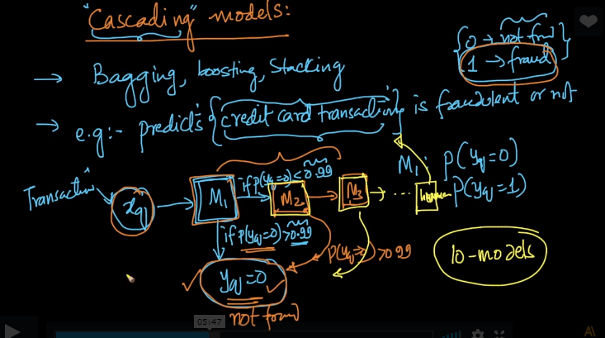

So we train one model if it says it is not fraud its ok but if there is slight possibility that it is fraud so we will train another model which is slight more complex than previous one and if it says it is not fraud than it is fine we will stop but if again there is some probability of it being fraud then the chain continuous and atlast if we are not sure than we call a human who is owner of credit card and ask him if he has actually made this transaction or not.

So this is basic steps followed for Cascading.

Another example can be Cancer patient.

We will train models to determine if person has cancer or not and if any model say “NO Cancer” than it’s fine but if there is still some confusion left at the end so we call a doctor (specialist) who will clarify the situation but this will reduce the work of doctor to very much extend and almost all the cases will be handled by model itself and only very few will come to doctor.

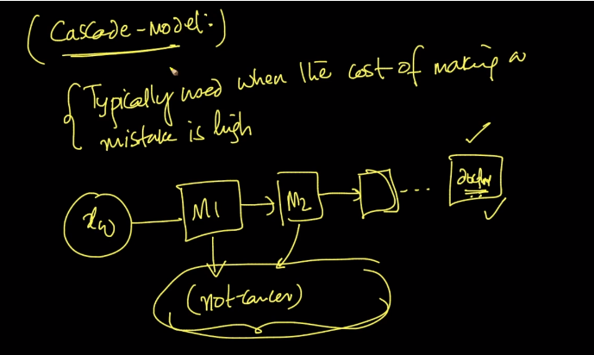

But there are few measures need to take care of i.e. the data used for training model M1 is whole different and small from data used to train model M2 and for M3 it will again be different and less because the outcomes which are predicted sure by one model need to be removed before passing data to another model for the points for which the model 1 is not sure.

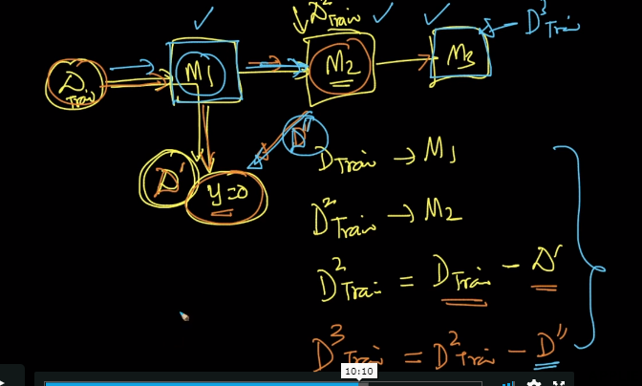

This is just one type of cascade but there are many types of cascades i.e.,

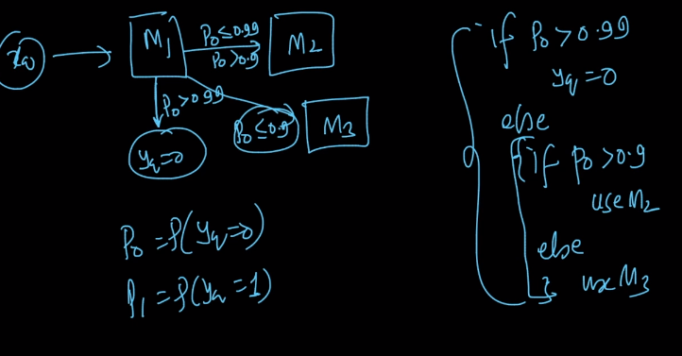

**Comments:**

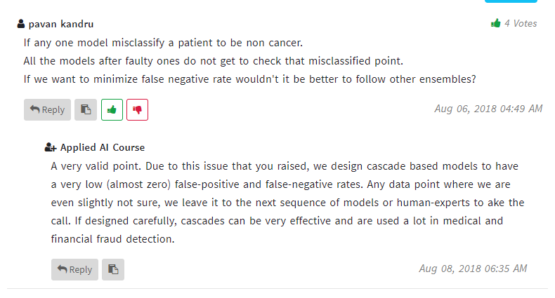

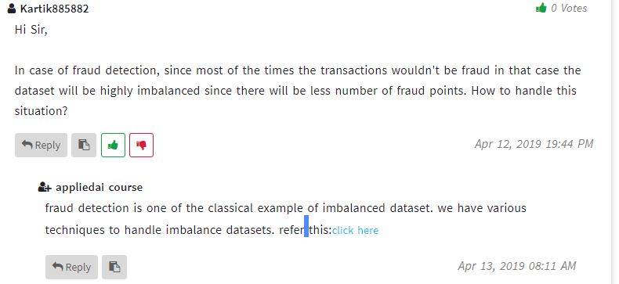

**Most important link to understand how to handle imbalanced datasets in any model.**

<https://machinelearningmastery.com/tactics-to-combat-imbalanced-classes-in-your-machine-learning-dataset/>

**How different measures work in case of imbalanced datasets.**

<https://machinelearningmastery.com/classification-accuracy-is-not-enough-more-performance-measures-you-can-use/>